ПРИЛОЖЕНИЕ А
Работа с базами данных. Технологии доступа к данным

Задание 1. Система бронирования отеля

Листинг программы:

<Window x:Class="HotelBooking.Views.MainWindow"
xmlns="http://schemas.microsoft.com/winfx/2006/xaml/presentation"
xmlns:x="http://schemas.microsoft.com/winfx/2006/xaml"
Title="HotelPro — Управление бронированием"
Height="780" Width="1280" MinHeight="650" MinWidth="1000"
WindowStartupLocation="CenterScreen"
Background="{StaticResource SurfaceBrush}">

<Grid>
<Grid.RowDefinitions>
<RowDefinition Height="56"/>
<RowDefinition Height="*"/>
<RowDefinition Height="36"/>
</Grid.RowDefinitions>
<Border Grid.Row="0" Background="{StaticResource PrimaryBrush}">
<Grid Margin="20,0">
<Grid.ColumnDefinitions>
<ColumnDefinition Width="Auto"/>
<ColumnDefinition Width="*"/>
<ColumnDefinition Width="Auto"/>
</Grid.ColumnDefinitions>
<StackPanel Orientation="Horizontal" VerticalAlignment="Center">
<TextBlock Text="🏨" FontSize="22" VerticalAlignment="Center" Margin="0,0,8,0"/>
<TextBlock Text="HotelPro" FontSize="20" FontWeight="Bold" Foreground="White" VerticalAlignment="Center"/>
</StackPanel>
<StackPanel Grid.Column="2" Orientation="Horizontal" VerticalAlignment="Center">
<TextBlock Text="👤 " Foreground="White" FontSize="13" VerticalAlignment="Center"/>

<TextBlock Text="{Binding ManagerName}" Foreground="White" FontSize="13" VerticalAlignment="Center" Margin="0,0,16,0"/>
<Button Content="Выйти" Click="LogoutButton_Click"
Background="Transparent" BorderThickness="0"
Foreground="White" FontSize="12" Cursor="Hand"/>
</StackPanel>
</Grid>
</Border>
<Grid Grid.Row="1" Margin="16">
<Grid.ColumnDefinitions>
<ColumnDefinition Width="*" MinWidth="480"/>
<ColumnDefinition Width="16"/>
<ColumnDefinition Width="360"/>
</Grid.ColumnDefinitions>

<!-- LEFT: Tabs with rooms / bookings -->
<Border Background="White" CornerRadius="12" Padding="0">
<Border.Effect>
<DropShadowEffect BlurRadius="12" ShadowDepth="2" Opacity="0.06"/>
</Border.Effect>
<Grid>
<Grid.RowDefinitions>
<RowDefinition Height="Auto"/>
<RowDefinition Height="Auto"/>
<RowDefinition Height="*"/>
</Grid.RowDefinitions>

Анализ результатов:
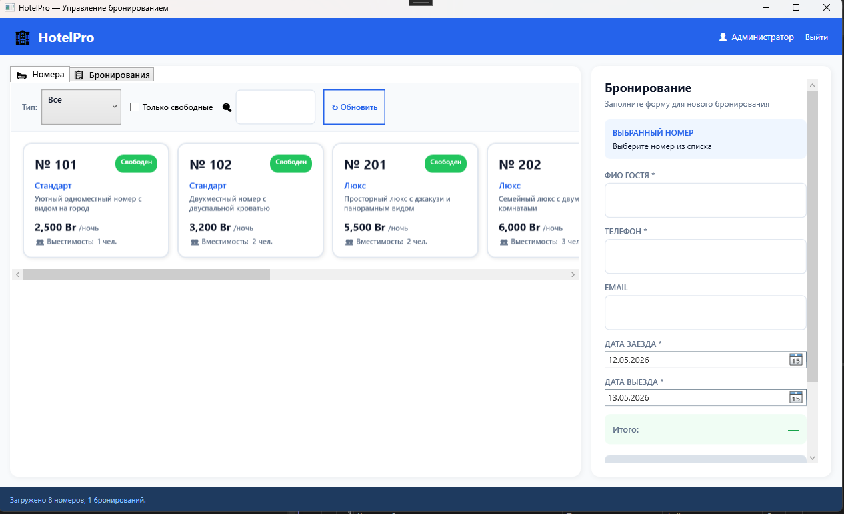
Рисунок 1.1 – Результат работы программы

